1.Define
(A)
(a) Class:
A class is a group of objects which have common properties. It is a template or blueprint from which objects are created. It is a logical entity. It can't be physical.
A class in Java can contain:
- fields
- methods
- constructors
- blocks
- nested class and interface

(b) Object:
An entity that has state and behavior is known as an object e.g. chair, bike, marker, pen, table, car etc. It can be physical or logical (tangible and intangible).
An object has three characteristics:
- state: represents data (value) of an object.
- behavior: represents the behavior (functionality) of an object such as deposit, withdraw etc.
- identity: Object identity is typically implemented via a unique ID. The value of the ID is not visible to the external user. But, it is used internally by the JVM to identify each object uniquely.
(c) Instance:
The new operator instantiates a class by allocating memory for a new object and returning a reference to that memory

(d) Instantiation:
In programming, instantiation is the creation of a real instance or particular realization of an abstraction or template such as a class of objects or a computer process. To instantiate is to create such an instance by, for example, defining one particular variation of object within a class, giving it a name, and locating it in some physical place.

(e) Constructor:
Constructor in java is a special type of method that is used to initialize the object.
Java constructor is invoked at the time of object creation. It constructs the values i.e. provides data for the object that is why it is known as constructor.
There are basically two rules defined for the constructor.
- Constructor name must be same as its class name
- Constructor must have no explicit return type
There are two types of constructors:
- Default constructor (no-arg constructor)
- Parameterized constructor
(f) Instance variable:
A variable which is created inside the class but outside the method, is known as instance variable. Instance variable doesn't get memory at compile time. It gets memory at run time when object(instance) is created. That is why, it is known as instance variable.

(g) Encapsulation:
Encapsulation is one of the four fundamental OOP concepts. The other three are inheritance, polymorphism, and abstraction.
Encapsulation in Java is a mechanism of wrapping the data (variables) and code acting on the data (methods) together as a single unit. In encapsulation, the variables of a class will be hidden from other classes, and can be accessed only through the methods of their current class. Therefore, it is also known as data hiding.
To achieve encapsulation in Java −
- Declare the variables of a class as private.
- Provide public setter and getter methods to modify and view the variables values.

(h) Abstraction:
Likewise in Object-oriented programming, abstraction is a process of hiding the implementation details from the user, only the functionality will be provided to the user. In other words, the user will have the information on what the object does instead of how it does it.

2. Write a java program to implement single-level inheretence ?
(A)
public class SingleInh
{
public static void main(String arg[])
{
B obj1 = new B();
obj1.methodB();
obj1.methodA();
}
}

class A
{
void methodA()
{
System.out.println("This is A");
}
}

class B extends A
{
void methodB()
{
System.out.println("This is B");
}
}

OUTPUT :

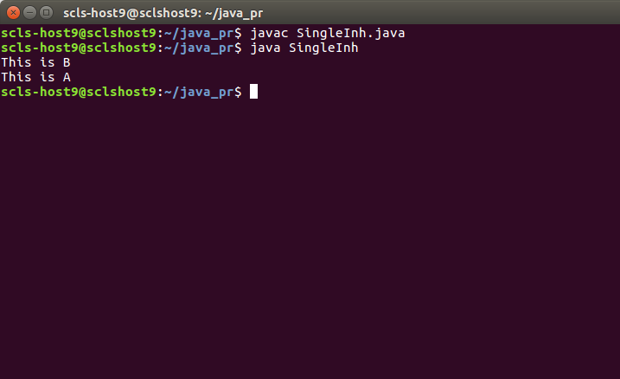
3. Write a java program to implement multi-level inherentence ?
(A).
public class MultiInh
{
public static void main(String arg[])
{
D obj1 = new D();
obj1.methodB();
obj1.methodA();
obj1.methodC();
obj1.methodD();
}
}

class A
{
void methodA()
{
System.out.println("This is A");
}
}

class B extends A
{
void methodB()
{
System.out.println("This is B");
}
}

class C extends B
{
void methodC()
{
System.out.println("This is c");
}
}

class D extends C
{
void methodD()
{
System.out.println("This is d");
}
}

OUTPUT :

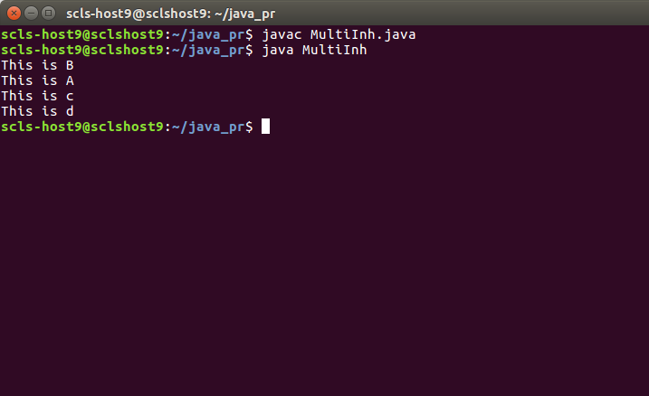

4. Write a java program to implement Hierarchical inheritence ?
(A).
public class HierarchicalInh
{
public static void main(String arg[])
{
B obj1 = new B();
obj1.methodA();
obj1.methodB();

C obj2 = new C();
obj2.methodA();
obj2.methodC();

D obj3 = new D();
obj3.methodA();
obj3.methodD();
}
}

class A
{
void methodA()
{
System.out.println("This is A");
}
}

class B extends A
{
void methodB()
{
System.out.println("This is B");
}
}

class C extends A
{
void methodC()
{
System.out.println("This is c");
}
}

class D extends A
{
void methodD()
{
System.out.println("This is d");
}
}

OUTPUT:

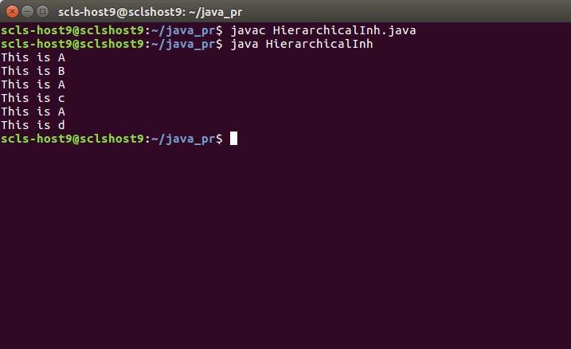
5. Write a java program with parameterized constructors in the following multiple inheritence in the following multiple inheritence
A -> B -> C -> D

(A)
public class SuperInh
{
public static void main(String arg[])
{
D obj = new D(10,20,30,40);
}
}

class A
{
A(int w)
{
System.out.println("w is "+w);
}
}

class B extends A
{
B(int w,int x)
{
super(w);
System.out.println("x is "+x);
}
}

class C extends B
{
C(int x,int w,int y)
{
super(x,w);
System.out.println("y is "+y);
}
}

class D extends C
{
D(int y,int x,int w,int z)
{
super(y,x,w);
System.out.println("z is "+z);
}
}

OUTPUT:

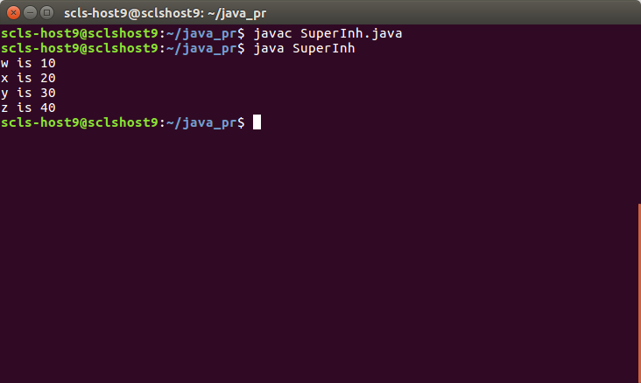
6. Prepare a document with following concepts.
(a) Inheritence
(b) Types of inheritence with examples
(c) Use of super keyword with example
(A)

(a) Inheritence:
Inheritance can be defined as the process where one class acquires the properties (methods and fields) of another. With the use of inheritance the information is made manageable in a hierarchical order.
The class which inherits the properties of other is known as subclass (derived class, child class) and the class whose properties are inherited is known as superclass (base class, parent class).
extends is the keyword used to inherit the properties of a class.
IS-A is a way of saying: This object is a type of that object.
If a class is inheriting the properties of another class, the subclass automatically acquires the default constructor of the superclass. But if you want to call a parameterized constructor of the superclass, you need to use the super keyword.

(b) Types of inheritances and examples(diagrams)
There are 4 types of inherentences. They are :
(1) Single Inheritance :
Single inheritance is damn easy to understand. When a class extends another one class only then we call it a single inheritance. The below flow diagram shows that class B extends only one class which is A. Here A is a parent class of B and B would be a child class of A.
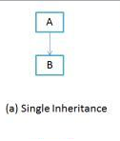

(2) Multi-level Inheritance :
Multi-level inheritance refers to a mechanism in OO technology where one can inherit from a derived class, thereby making this derived class the base class for the new class. As you can see in below flow diagram C is subclass or child class of B and B is a child class of A.

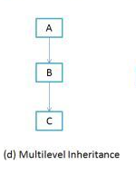

(3) Hierarchical inheritance :
In such kind of inheritance one class is inherited by many sub classes. In below example class B,C and D inherits the same class A. A is parent class (or base class) of B,C & D.
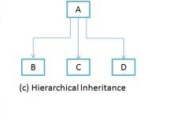

(4) Multi-level inheritance :
“Multiple Inheritance” refers to the concept of one class extending (Or inherits) more than one base class. The inheritance we learnt earlier had the concept of one base class or parent. The problem with “multiple inheritance” is that the derived class will have to manage the dependency on two base classes.
Note 1: Multiple Inheritance is very rarely used in software projects. Using Multiple inheritance often leads to problems in the hierarchy. This results in unwanted complexity when further extending the class.
Note 2: Most of the new OO languages like Small Talk, Java, C# do not support Multiple inheritance. Multiple Inheritance is supported in C++.
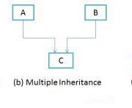

(C) Use of super keyword with example.
(A)
It is used inside a sub-class method definition to call a method defined in the super class. Private methods of the super-class cannot be called.
Only public and protected methods can be called by the super keyword.
It is also used by class constructors to invoke constructors of its parents class.
Eg:
public class SuperInn1
{
public static void main(String arg[])
{
D1 obj = new D1(10,20,30,40);

System.out.println(obj.d);
System.out.println(obj.c);
System.out.println(obj.b);
System.out.println(obj.a);
}
}

class A1
{
int a;

A1(int w)
{a=w;

}
}

class B1 extends A1

{
int b;
B1(int w,int x)
{
super(w);
b = x;
}
}

class C1 extends B1
{
int c;
C1(int x,int w,int y)
{

super(x,w);
c = y;
}
}

class D1 extends C1
{
int d;
D1(int y,int x,int w,int z)
{ super(y,x,w);
d = z;
}
}

OUTPUT :

